Target Abstraction Layer
Getting Started
Copyright © 2026, Imagination Technologies Ltd. All Rights Reserved.
This publication contains proprietary information which is protected by copyright. The information contained in this publication is subject to change without notice and is supplied 'as is' without warranty of any kind. Imagination Technologies and the Imagination Technologies logo are trademarks or registered trademarks of Imagination Technologies Limited. All other logos, products, trademarks and registered trademarks are the property of their respective owners.
Filename : 0000.doc
Version : 1.0.8 Not Issued - Live Document
Issue Date : 12 Sep 2011
Author : Imagination Technologies
Contents
1. Introduction 4
1.1. Toolset overview 5
1.2. Definitions 6
2. Overview 7
2.1. Test Targets 7
2.2. Tests 7
2.3. Target Abstraction Layer (TAL) API 7
2.4. Target API 7
2.5. Wrapper API 8
2.6. PDUMP API 8
2.7. PDUMP Player 8
3. TAL Implementations 9
3.1. “Normal” TAL 9
3.2. “Light” TAL 9
4. Key Features 10
4.1. Error handling 10
4.2. Memory spaces 10
4.3. Memory Space Names and Memory Space IDs 10
4.4. Internal registers 10
4.5. Address mangling 10
4.6. Check functions 11
4.7. Device memory 11
4.8. PDUMP Capture 11
5. Simple DMAC Example 12
5.1. Example Direct Memory Access Controller (DMAC) 12
5.1.1. Destination Address (DEST) 12
5.1.2. Control (CONTROL) 12
5.1.3. Status (STATUS) 12
5.2. Example code 13
5.3. Example PDUMP Output 16
6. Notes on PDUMP output 17
6.1. Applying filters to the capture 17
6.2. Making asynchronous operations synchronous 17

IF{{Internal}}
$Revision: 1.2 $
Document History
Issue | Date | Changes/Comments
0.1.1a | 04 Feb 2004 | First Version.
1.0.4 | 27 Feb 2009 | External Issue
END{{Internal}}

Introduction
This document is the “getting started” guide to the Target Abstraction Layer (TAL). The guide provides an overview of the key concepts of the TAL and some simple examples. It is not meant to be a reference for the full suite of TAL functions – users should refer to the TAL header file which can be found in:

<package>/target/include

(examples of <package> include “consumer_av”, “con_av_neutrino_d”, “powervr_tools”)

The TAL is a crucial component in an integrated toolset designed to expedite both hardware and software development. To the uninitiated it can be difficult to understand the rationale for developing software using the TAL but as familiarity with the concepts increases and appreciation of the TAL’s place within the larger toolset grows the benefits will become apparent

The TAL’s primary function is to abstract the interface between the driver, API or test applications and the target device (block of IP). All register and memory accesses relating to the target device pass through the TAL and can be captured as a PDUMP2 script and/or routed to the instantiation of the target device which may be:
- a software simulator
- an rtl simulation
- rtl running on an FPGA system
- the final rtl embodied within an SoC

Note: This document assumes that the user will read this document in conjunction with the PowerVR Tools.Pdump2 Script Functions specification which describes the PDUMP2 scripting functions. As you use the TAL it will become obvious how the TAL functions map onto the scripting language.

Toolset overview
The interrelationship between the various tools which comprise the toolset is shown below:

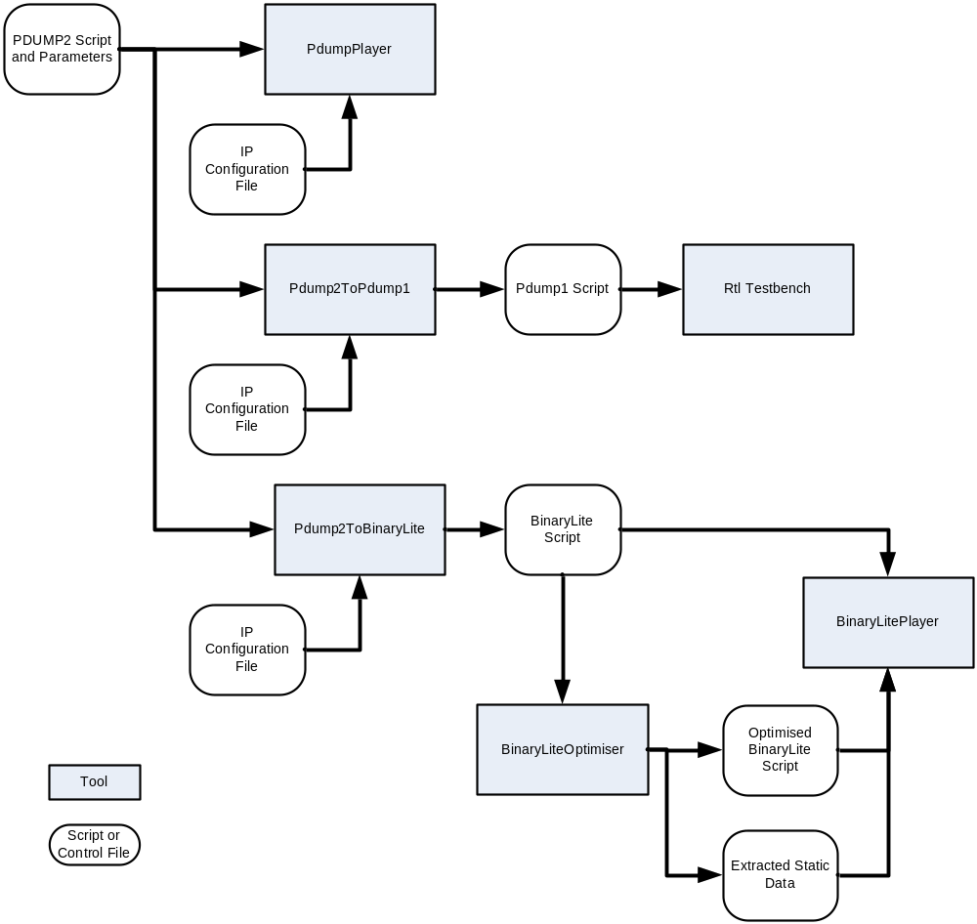

The TAL is used in the first instance to generate the PDUMP2 script and parameters by executing tests on any suitable target and enabling the PDUMP output feature of the TAL. (This, of course, requires that the test application and/or drivers use the TAL appropriately).

The TAL is also used by the PdumpPlayer itself for replaying of previously recorded scripts, and by the Pdump2ToPdump1 and Pdump2toBinaryLite convertors.

Definitions

Device
A part of a device (block of IP) that can be embodied in a variety of ways
Host
The platform on which the test application or drivers are run
Target
The platform or platforms on which the devices under test can be instantiated
Tests
Test applications, drivers and associated data.

Overview
The diagram below shows the how the TAL interface might be used:
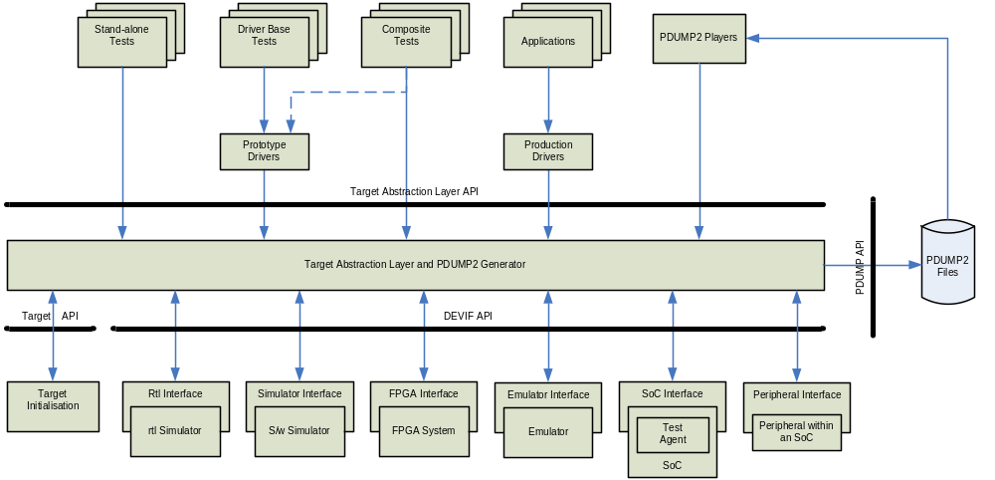

Test Targets
As can be seen from the diagram a variety of targets exist on which tests can be run.
The targets include:
- the rtl block running on a simulator
- the software simulator of the IP block
- an FPGA system containing an image of the rtl block
- the emulator containing an image of the rtl block
- the final SoC

Note: This list is not exhaustive, but represents the more general cases. For example, on other projects a player has been implemented that runs on the embedded processor in rtl simulation.

Tests
Tests can be stand-alone, based on the use of a prototype driver or can use the driver for some functions but may require access to registers in order to set up a mode or setting not supported by the driver.

Target Abstraction Layer (TAL) API
The TAL API abstracts register and memory accesses relating to the parameters and control of the device.
The PDUMP2 Generator is part of the TAL and can be used to generate PDUMP2 and PDUMP1 output to record these accesses.

PDUMP2 Files
The PDUMP2 files contain a scripted set of parameter settings and control and supporting data needed to fully recreate the environment and setup for a test.

Target API
The Target API allows the devices to be registered with the TAL. Some tools use a “Target Configuration File” to define the memory map of the target; others embed the target information within the tool.

DEVIF API
The DEVIF API is designed to present a common, simple interface to the devices below the TAL.

PDUMP API
The PDUMP API abstracts the PDUMP2 file access and allows this to be implemented in a system specific way – to hard disk, memory etc.

Test Agent
On SoCs containing an embedded processor, the Test Agent is a small software agent that performs memory and register operations on the target on behalf of the TAL.

PDUMP2 Player
Is a program that can be used to replay PDUMP2 scripts. It uses the Target Abstraction Layer APIs so that it can be used to drive any target supporting the DEVIF API.

TAL Implementations
There are currently three implementations of the TAL API; the “normal”, “portability framework” and “light” TAL. The functionality varies according to the target environment.
An additional implementation is possible which would be even lighter than the “light” version and would remove the address translation. This would be more suited to MTX-type systems.
The implementation of the TAL required to be built can be selected using the TAL_TYPE parameter in cmake. The default value is “normal”. The code for the TAL and surrounding code, the CMakeList.txt file and the Cmake findPackage file can all be found in:

<package>/target

“Normal” TAL
The “normal” implementation provides the means of capturing parameters as PDUMP scripts, it also uses the DEVIF interface which allows one of a range of interfaces to be selected at runtime. The primary use of this implementation is when developing the drivers or APIs and test applications.

“Portability Framework” TAL
This version of the TAL needs to be used for the kernel mode driver when using the portability framework. In order to use this function the portability framework must be setup, separate documentation is available for this if required. In most cases this version will not be needed.

“Light” TAL
The “light” implementation is for use in embedded systems. This implements the TAL APIs, but register read/writes are through simple memory mapped accesses to the device. The device memory functions are mostly stubs, although the implementation does handle the virtual to physical address translation via the CPU’s MMU. The “light” implementation does not implement the PDUMP2 capabilities or the DEVIF API. The primary use of this implementation is for Meta based systems typically running MeOS or Nucleus.

Key Features
The following sections describe some of the key features of the TAL.

Error handling
In general, asserts are used to trap and report errors detected by the TAL. This removes the need for the driver, API or test program to check the return value. This includes unexpected errors reported by the underlying layers. In the event that the returned value is other than IMG_SUCCESS then this will be an event that the user should expect and will be clearly documented as a possible return value from the TAL function.

Memory spaces
Devices are assumed to have one or more memory spaces, which might include:
- Device register blocks
- The device’s view of system memory (which may be different from the processors view)
The concept of memory spaces exists primarily to support relocation of tests/scripts within the overall toolset. The reason why tests/scripts need to be relocated is so that the same proven tests can be run without any modification both internally and by IP licensees themselves on a variety of targets with potentially different memory maps.

Memory Space Names and Memory Space IDs
All memory spaces are “named”. There is a TAL function used to convert the name into a memory space ID, which is used in the majority of the remaining TAL functions. The names are made known to the TAL when the memory spaces are registered with the TAL from the TARGET_Initialise function.
Note: There are many possible different implementations of the TARGET_Initialise function and the way in which memory space names are defined and associated with real addresses is not necessarily consistent across all implementations. One method uses an external configuration file, another method may hard-code this information.

Internal registers
The TAL incorporates the concept of “Internal Registers” which are 64-bit entities which are stored within the TAL. These can be set, and manipulated by a range of mathematical and logical operations and then written to a memory or register. Each memory space has an independent set of these registers.
A key use for these internal registers is for an address which needs to be masked and shifted before being loaded into a h/w register. Using the internal registers and associated functions within the TAL to achieve this allows operations to be performed within a generated pdump2 script as well as when run directly through the TAL. The operation is then repeatable on values which are not known in advance of the test such as allocated memory.

Address mangling
Address mangling has been removed from the TAL and the same functionality can be reproduced using internal registers.

Check functions
Check functions are no longer supported. For polling, check functions were required to perform the necessary shifts, masking, logical and comparison operations to determine whether an event has occurred. As for address mangling, this is also no longer the recommended method of implementing complex comparisons. – we would now recommend the internal registers are used to manipulate and combine values to be checked and the loop construct used to implement the final “test”. See “Internal registers” above.

Device memory
The TAL is designed to support both unified and non-unified memory systems in a consistent manner, and in a manner which makes all accesses to memory visible to the TAL and therefore capable of being recorded (as a PDUMP2 script) for subsequent replay. In order to do this it is imperative that all allocations of and accesses to device memory are performed via the appropriate TAL functions. Additionally, it is essential that all code is developed as if the memory system is non-unified regardless of its true nature. In unified memory systems this may seem to incur the penalty of needless memory copying but in reality there is no actual memory copying performed.
In general the scheme is as follows:
- The test/driver will allocate a buffer or block of host memory that contains data to be accessed by the device.
- A block of device memory is allocated via the TAL and the device memory updated via the TAL (this will “copy” the contents of the test/driver buffer to the device memory).
- The device will then be enabled and will operate on the data it has been passed.
- Having completed the operation the test/driver can view any changes to the buffer by using the TAL to “copy” the device memory back to the host.

It is the test application or drivers responsibility to use the TAL to copy data to/from device memory when the contents have changed or been updated by either the host or device.

Memory Allocation
The default memory scheme for the TAL assumes that a device has been given a large chunk of memory and the TAL gets to use its own allocation scheme in order to divide up the memory. This is usually the case when running on a simulation or FPGA as there will be access to the whole PCI or simulated device memory. The different allocation schemes such as random allocation are described in the DEVICE section of the Target Config File document.
If the device memory is part of the system memory there are two possible schemes, the first uses the concept of “burning memory” where part of the system memory is allocated at boot time to the device so it is not used by the operating system for anything else. The second method allows the allocation to take place outside of the TAL. This method relies upon an external allocator, of which there is an implementation in our linux driver which allows the operating system to allocate memory for the device to use.
NOTE: Allocation of memory through the operating system is only possible if the device has an MMU.

PDUMP Capture
The full TAL implementation contains a means of capturing PDUMP2 parameters, scripts and control information. The captured data can be used in rtl testing etc.

Simple DMAC Example
The following section contains example code for a simple DMAC.

Example Direct Memory Access Controller (DMAC)
Summary of DMAC registers described here:
Register name | Offset | Properties | Reset value
SRC
0x0000 | R/W | 0x00000000
DEST
0x0004 | R/W | 0x00000000
CONTROL
0x0008 | R/W | 0x00000000
STATUS
0x000C | R/W | 0x00000000
Source Address (SRC)
Offset: 0x0000
Reset Value: 0x00000000
Access: Can be read/written at any time
Bit(s) | Symbol | Description
31:0 | ADDRESS | Source address should be 16-byte aligned. Bits 3:0 should be 0.

Destination Address (DEST)
Offset: 0x0004
Reset Value: 0x00000000
Access: Can be read/written at any time
Bit(s) | Symbol | Description
31:0 | ADDRESS | Destination address should be 16-byte aligned. Bits 3:0 should be 0.

Control (CONTROL)
Offset: 0x0008
Reset Value: 0x00000000
Access: Can be read/written at any time
Bit(s) | Symbol | Description
31:1 | - | Reserved
0 | ENABLE | Set to 1 to enable DMAC transfer

Status (STATUS)
Offset: 0x000C
Reset Value: 0x00000000
Access: Can be read/written at any time
Bit(s) | Symbol | Description
31:1 | - | Reserved
0 | COMPLETE | Set to 1 when transfer completes

Example code
The following are variables used in the example.

Note: The example DMAC requires source and destination buffers to be 16-byte aligned, so large buffers have been allocated and the pointers paAlignedSrc and paAlignedDest set to 16-byte aligned addresses. The TAL does not check the alignment of the host side buffers, although they would need to be correctly aligned for the example code to work in a system with unified memory.

IMG_UINT32 i;

/* Memory space Ids */
IMG_UINT32 ui32RegDmacId;
IMG_UINT32 ui32MemDmacId;

/* Used to return the previous state */
IMG_BOOL bPrevState;

/* 16-byte aligned source and destination buffers */
static IMG_CHAR acSrc[48];
static IMG_CHAR acDest[48];
IMG_CHAR * paAlignedSrc = (IMG_CHAR*) ((IMG_UINT32)&acSrc & ~0x0000000F);
IMG_CHAR * paAlignedDest = (IMG_CHAR*) ((IMG_UINT32)&acDest & ~0x0000000F);

/* Handles to device memory */
IMG_HANDLE hDeviceMemSrc;
IMG_HANDLE hDeviceMemDest;

The following block of code initializes the TAL, enables the capture of PDUMP2 parameters if PDUMP_PARAMETERS is defined, and obtains the required memory space ids:

/* Initialise TAL...*/
TAL_Initialise ();

/* Enable capture of PDUMP2 parameters...*/
#ifdef PDUMP_PARAMETERS
TAL_CaptureEnableOutputFormats(IMG_FALSE, IMG_TRUE);
TAL_CaptureMemSpaceEnable(TAL_MEMSPACE_ID_ALL, IMG_TRUE, &bPrevState);
TAL_CaptureStart("");
#endif

/* Get the DMAC register and memory Ids. Normally this would be done
once at the start of the program...*/
TAL_MemSpaceGetId ("REG_DMAC", &ui32RegDmacId);
TAL_MemSpaceGetId ("MEM_DMAC", &ui32MemDmacId);

The following allocates device memory for the source and destination buffers previously allocated (statically) in host memory:

/* Allocate device memory for the source and destination buffers */
TAL_MallocDeviceMem(ui32MemDmacId,
paAlignedSrc, /* Pointer to aligned buffer */
32, /* Size */
16, /* Alignment, 16-byte */
&hDeviceMemSrc, /* Pointer to returned handle */
IMG_FALSE); /* Don't update device memory */

TAL_MallocDeviceMem(ui32MemDmacId,
paAlignedDest, /* Pointer to aligned buffer */
32, /* Size */
16, /* Alignment, 16-byte */
&hDeviceMemDest, /* Pointer to returned handle */
IMG_FALSE); /* Don't update device memory */

The following fills the source buffer and copies the contents of the host-based source buffer to the device allocation associated with the source buffer:

/* Fill source buffer with 0 to 31...*/
for (i=0; i<32; i++)
{
paAlignedSrc[i] = i;
}

/* Copy the content of the source buffer to the region of
device memory allocated to this buffer...*/
TAL_CopyHostToDeviceMem(ui32MemDmacId, hDeviceMemSrc);

The following sets up the source and destination addresses to be used by the DMAC – these are set by referencing the device memory associated with the buffers via the handles hDeviceMemSrc and hDeviceMemDest:

/* Setup the source and destination address registers...*/
TAL_WriteDeviceMemRef(ui32RegDmacId,
0x0000, /* Register offset */
TAL_NULL_MANGLER_ID, /* No mangling required */
hDeviceMemSrc, /* Handle for source buffer */
0x0000); /* Offset */
TAL_WriteDeviceMemRef(ui32RegDmacId,
0x0004, /* Register offset */
TAL_NULL_MANGLER_ID, /* No mangling required */
hDeviceMemDest, /* Handle for destination buffer */
0x0000); /* Offset */

The following inserts a comment into the PDUMP script (if PDUMP capture is enabled) and starts the DMAC transfer:

/* Start the DMAC transfer...*/
TAL_PdumpComment(ui32RegDmacId, "Start DMAC transfer");
TAL_WriteWord (ui32RegDmacId,
0x0008, /* Register offset */
0x0001); /* Enable DMAC */

The following polls for the completion of the DMAC transfer:

/* Wait for the DMAC transfer to complete...*/
TAL_Poll(ui32RegDmacId,
0x000C, /* Register offset */
TAL_CHECKFUNC_ISEQUAL, /* Check for == */
0x00000001, /* The required value */
0x00000001, /* Enable mask */
100, /* Max number of times to repeat the poll */
10); /* Delay, in clock cycles, between polls */

The following copies the device memory associated with the destination buffer to the buffer in host memory – allowing the results of the DMAC to be accessed in the host buffer:

/* Copy the content of the region of device memory allocated to
the destination buffer back to the host. At this point the
aligned part of the destination buffer should contain 0 to 31...*/
TAL_CopyDeviceToHostMem(ui32MemDmacId, hDeviceMemDest);

The following frees the device memory:

/* Free the device memory...*/
TAL_FreeDeviceMem(&hDeviceMemSrc);
TAL_FreeDeviceMem(&hDeviceMemDest);

The following disables the PDUMP capture

/* Stop PDUMP capture */
#ifdef PDUMP_PARAMETERS
TAL_CaptureStop();
#endif

Example PDUMP Output
In the DMAC example the TAL would generate three files containing PDUMP parameters:
out2.txt – contains the PDUMP2 scripts
out2.prm – contains the values to be “loaded” via LBD’s in the scripts
out2.res – contains the values to be “verified” via SAB’s in the script

Note: Information captured in the out2.res can be used when playing back the script in regression runs to check that the same values are generated in the destination buffer.

The following shows the content of the out2.txt file for the example DMAC code:

MALLOC :MEM_DMAC:BLOCK_0 32 16
MALLOC :MEM_DMAC:BLOCK_1 32 16
LDB :MEM_DMAC:BLOCK_0 0 out2.prm
WRW :REG_DMAC:0x0 :MEM_DMAC:BLOCK_0:0x0
WRW :REG_DMAC:0x4 :MEM_DMAC:BLOCK_1:0x0
-- Start DMAC transfer
WRW :REG_DMAC:0x8 0x1
POL :REG_DMAC:0xC 0x1 0x1 0 100 10
SAB :MEM_DMAC:BLOCK_1 0 out2.res -- offset 0x00000000
FREE :MEM_DMAC:BLOCK_0
FREE :MEM_DMAC:BLOCK_1

Notes on PDUMP output

Applying filters to the capture
The TAL allows filters to be applied to the captured output. You can filter by only enabling capture for certain memory spaces. In addition, you can exclude certain commands for the output (for example register reads are often of little value in PDUMP scripts, so the capturing of RDW commands can be disabled). TAL functions are used to enable the filter settings.

Making asynchronous operations synchronous
The PDUMP scripts are effectively synchronous when being played back with the player or rtl testbench. There is no concept of “wait for interrupt”, so a means of generating synchronous PDUMP output needs to be found if the drivers/APIs are to be used for generating PDUMP scripts.

One solution used for LISRs (low-level interrupt service routines) is to read the interrupt status at the start of the ISR and to immediately follow this with a “POL” of the status register for the value read. This means that the PDUMP script will synchronise at this point waiting for the interrupt to occur.

It may be found that additional work is needed to ensure that valid, “runnable” scripts are generated – particularly when there are several sub-blocks in the IP that are running asynchronously.

Porting the Target Abstraction Layer (TAL)
NOTE: If the package you are using uses the Portability Framework then you should not need to port the TAL the “Portability Framework” version should be appropriate for most applications.

Porting of the TAL involves the development of a TAL implementation for your platform. More than likely this will be based on the “light” implementation (see or APIs and test applications. ). You should follow the following steps:
- Before starting it is recommended that you first build and link the drivers or APIs from IMG that use the TAL in order to determine the sub-set of TAL functions referenced by the drivers or APIs – these will be listed as undefined functions and are the sub-set of the TAL functions you need to implement
- Create a copy of the appropriate version of the TAL and remove any functions not referenced by the drivers or APIs
- Modify the code to provide the require functionality but implement for your platform
- Create a simple test application to test you TAL implementation – starting with basic register accesses and progressing to the more complex functions
- Build and test your implementation with the drivers or APIs.

